The Two basic, most popular methodologies used in software Development Life Cycle (SDLC) are:

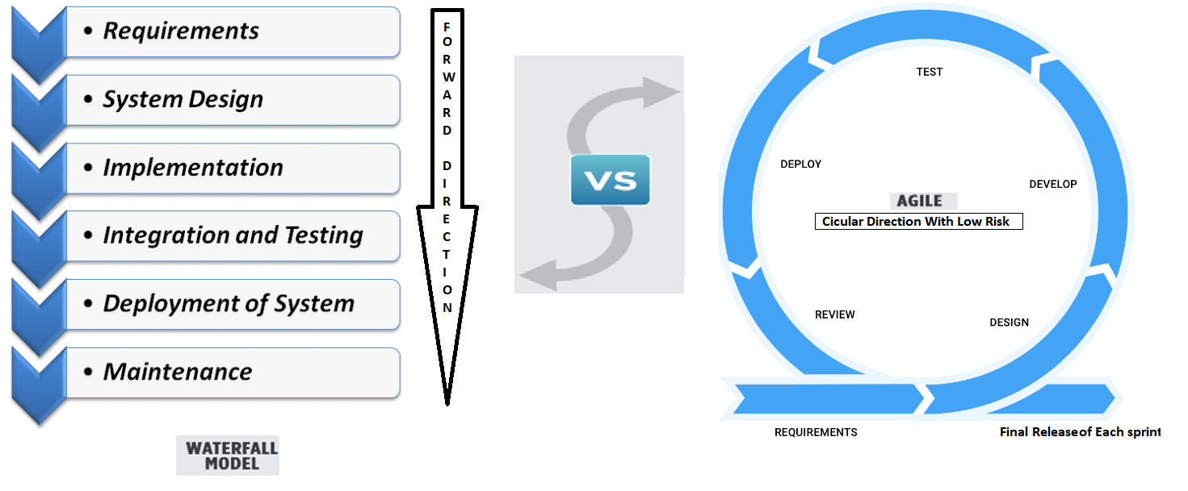

**The Waterfall Methodology**

***Waterfall***is a linear approach to software development. In this methodology, the sequence of events is something like:

1. **Requirements**
2. **Design**
3. **Coding**
4. **Testing**
5. **Deployment**
6. **Maintenance**

**The Agile Methodology**

[**Agile**](https://www.seguetech.com/blog/2013/04/05/what-is-agile-software-development) is an iterative, team-based approach to development. This approach emphasizes the rapid delivery of an application in complete functional components.

|  |  |
| --- | --- |
| **Agile** | **Waterfall** |
| It separates the project development lifecycle into sprints. | Software development process is divided into distinct phases. |
| It follows an incremental approach | Waterfall methodology is a sequential design process. |
| Agile methodology is known for its flexibility. | Waterfall is a structured software development methodology so most times it can be quite rigid. |
| Agile can be considered as a collection of many different projects. | Software development will be completed as one single project. |
| Agile is quite a flexible method which allows changes to be made in the project development requirements even if the initial planning has been completed. | There is no scope of changing the requirements once the project development starts. |
| Agile methodology, follow an iterative development approach because of this planning, development, prototyping and other software development phases may appear more than once. | All the project development phases like designing, development, testing, etc. are completed once in the Waterfall model. |
| Test plan is reviewed after each sprint | The test plan is rarely discussed during the test phase. |
| Agile development is a process in which the requirements are expected to change and evolve. | The method is ideal for projects which have definite requirements and changes not at all expected. |
| In Agile methodology, testing is performed concurrently with software development. | In this methodology, the "Testing" phase comes after the "Build" phase |
| Agile introduces a product mindset where the software product satisfies needs of its end customers and changes itself as per the customer's demands. | This model shows a project mindset and places its focus completely on accomplishing the project. |
| Agile methdology works exceptionally well with Time & Materials or non-fixed funding. It may increase stress in fixed-price scenarios. | Reduces risk in the firm fixed price contracts by getting risk agreement at the beginning of the process. |
| Prefers small but dedicated teams with a high degree of coordination and synchronization. | Team coordination/synchronization is very limited. |
| Products owner with team prepares requirements just about every day during a project. | Business analysis prepares requirements before the beginning of the project. |
| Test team can take part in the requirements change without problems. | It is difficult for the test to initiate any change in requirements. |
| Description of project details can be altered anytime during the SDLC process. | Detail description needs to implement waterfall software development approach. |
| The Agile Team members are interchangeable, as a result, they work faster. There is also no need for project managers because the projects are managed by the entire team | In the waterfall method, the process is always straightforward so, project manager plays an essential role during every stage of SDLC. |
| Focus on Decision maker Hierarchy | Didn’t Focus on Decision maker Hierarchy |
| Technical Skill is Mandatory and Priority | Technical Skill isn’t Mandatory and Priority |

List of Document which is required

1. **Requirements Gathering Document**
   1. [**Document[see:- BRS _Document.docx]**](BRS%20_Document.docx)
2. **Design Document**
   1. [**Document[see:- TechnicalDesign_document.docx]**](TechnicalDesign_document.docx)
3. **Coding Document**

In the coding phase, tasks are divided into units or modules and assigned to the various developers. It is the longest phase of the Software Development Life Cycle process.

In this phase, Developer needs to follow certain predefined coding guidelines. They also need to use programming tools like compiler, interpreters, debugger to generate and implement the code.

Focus on multiple aspect:

* 1. Neat and clean code.
  2. Reduce the server code.
  3. User Interface code only for input data no need to do complex code in c#.
  4. Avoid create of multiple class which is also use the resources.
  5. Focus on Performance either winform or webform.
  6. Many more after facing a lot of issues during coding phase.
  7. Document
     1. [**Work divide into sprint[See : -Project Plan_Document.xlsx]**](Project%20Plan_Document.xlsx) **It contain 2 Form**
     2. [**To do List[see:- To-do-list.xlsx]**](To-do-list.xlsx)**: It contain 2 Form**

1. **Testing Document**
   1. **Programmer and Tester plan** 
      1. [**Test Plan[See: - Test-Case-Planning-and-Execution.xlsx]**](Test-Case-Planning-and-Execution.xlsx)
      2. [**SQL Server Test Plan[See: - SQLSERVER_Testing Document.xlsx]**](SQLSERVER_Testing%20Document.xlsx)
      3. [**3rd party Test Plan[See: -Third PartyControl_Testing Document.xlsx]**](Third%20PartyControl_Testing%20Document.xlsx)
   2. [**UAT -Test Plan[See: - UAT-Sheet.xlsx]**](UAT-Sheet.xlsx)
   3. [**UAT- Document [See : -** **User Acceptance Test Plan.docx]**](User%20Acceptance%20Test%20Plan.docx)
2. **Deployment Document**
   1. [**Hand Over Document[see :-** **Handover_Form.docx]**](Handover_Form.docx)
3. **Maintenance Document** 
   1. **After Deployment any issue and enhancement will come then User can send a request for support of Application.**
      1. [**Request form [see : -Project Change Request Form.docx]**](Project%20Change%20Request%20Form.docx)
      2. [**Contain all Request as a Log file [see : - Request Log.docx]**](Request%20Log.docx)